РГЗ 2, задание 3, вариант 6;

Выполнил Горбенко К.Н., группа ИВТ/б-12о.

Для данного графа провести кратчайшую раскраску вершин:

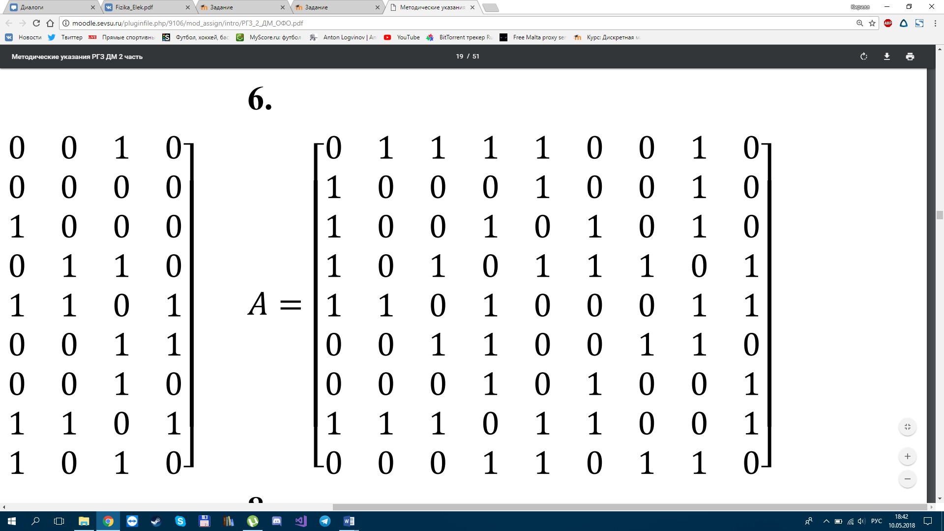

Внутренне устойчивые множества вершин графа:

|  |  |  |  |  |  |  |  |  |  |
| --- | --- | --- | --- | --- | --- | --- | --- | --- | --- |
| **x1** | **x2** | **x3** | **x4** | **x5** | **x6** | **x7** | **x8** | **x9** |  |
| 1 |  |  |  |  | 1 |  |  | 1🡾 | y1 |
| 1 |  |  |  |  |  | 1🡾 |  |  | y2 |
| 1🡾 |  |  |  |  |  |  |  |  | - y $⊆$ y1 |
|  | 1 | 1 |  |  |  | 1🡾 |  |  | y3 |
|  | 1 |  | 1🡾 |  |  |  |  |  | y4 |
|  | 1 |  |  |  | 1 |  |  | 1🡾 | y5 |
|  | 1🡾 |  |  |  |  |  |  |  | - y $⊆$ y3 |
|  |  | 1 |  | 1 |  | 1🡾 |  |  | y6 |
|  |  | 1 |  |  |  |  |  | 1🡾 | y7 |
|  |  | 1🡾 |  | ` |  |  |  |  | - y $⊆$ y6 |
|  |  |  | 1 |  |  |  | 1🡾 |  | y8 |
|  |  |  | 1🡾 |  |  |  |  |  | - y $⊆$ y8 |
|  |  |  |  | 1 | 1🡾 |  |  |  | y9 |
|  |  |  |  | 1 |  | 1🡾 |  |  | - y $⊆$ y6 |
|  |  |  |  | 1🡾 |  |  |  |  | - y $⊆$ y9 |
|  |  |  |  |  | 1 |  |  | 1🡾 | - y $⊆$ y5 |
|  |  |  |  |  | 1🡾 |  |  |  | - y $⊆$ y10 |
|  |  |  |  |  |  | 1 | 1🡾 |  | y10 |
|  |  |  |  |  |  | 1🡾 |  |  | - y $⊆$ y11 |
|  |  |  |  |  |  |  | 1🡾 |  | - y $⊆$ y11 |
|  |  |  |  |  |  |  |  | 1🡾 | - y $⊆$ y10 |

Составляем таблицу покрытий:

|  |  |  |  |  |  |  |  |  |  |
| --- | --- | --- | --- | --- | --- | --- | --- | --- | --- |
|  | **х1** | **х2** | **х3** | **х4** | **х5** | **х6** | **x7** | **x8** | **x9** |
| y1 | 1 |  |  |  |  | 1 |  |  | 1 |
| y2 | 1 |  |  |  |  |  | 1 |  |  |
| y3 |  | 1 | 1 |  |  |  | 1 |  |  |
| y4 |  | 1 |  | 1 |  |  |  |  |  |
| y5 |  | 1 |  |  |  | 1 |  |  | 1 |
| y6 |  |  | 1 |  | 1 |  | 1 |  |  |
| y7 |  |  | 1 |  |  |  |  |  | 1 |
| y8 |  |  |  | 1 |  |  |  | 1 |  |
| y9 |  |  |  |  | 1 | 1 |  |  |  |
| y10 |  |  |  |  |  |  | 1 | 1 |  |

Разложим по столбцу x1:

{y2}

{y1}

|  |  |  |  |  |  |  |
| --- | --- | --- | --- | --- | --- | --- |
| R11 | **х2** | **х3** | **х4** | **х5** | **x7** | **x8** |
| y2 |  |  |  |  | 1 |  |
| y3 | 1 | 1 |  |  | 1 |  |
| y4 | 1 |  | 1 |  |  |  |
| y5 | 1 |  |  |  |  |  |
| y6 |  | 1 |  | 1 | 1 |  |
| y7 |  | 1 |  |  |  |  |
| y8 |  |  | 1 |  |  | 1 |
| y9 |  |  |  | 1 |  |  |
| y10 |  |  |  |  | 1 | 1 |

|  |  |  |  |  |  |  |  |
| --- | --- | --- | --- | --- | --- | --- | --- |
| R12 | **х2** | **х3** | **х4** | **х5** | **х6** | **x8** | **x9** |
| y1 |  |  |  |  | 1 |  | 1 |
| y3 | 1 | 1 |  |  |  |  |  |
| y4 | 1 |  | 1 |  |  |  |  |
| y5 | 1 |  |  |  | 1 |  | 1 |
| y6 |  | 1 |  | 1 |  |  |  |
| y7 |  | 1 |  |  |  |  | 1 |
| y8 |  |  | 1 |  |  | 1 |  |
| y9 |  |  |  | 1 | 1 |  |  |
| y10 |  |  |  |  |  | 1 |  |

{y2, y8}

|  |  |  |  |  |  |
| --- | --- | --- | --- | --- | --- |
| R12 | **х2** | **х3** | **х5** | **х6** | **x9** |
| y3 | 1 | 1 |  |  |  |
| y5 | 1 |  |  | 1 | 1 |
| y6 |  | 1 | 1 |  |  |
| y7 |  | 1 |  |  | 1 |
| y9 |  |  | 1 | 1 |  |

{y1, y6}

|  |  |  |  |
| --- | --- | --- | --- |
| R11 | **х2** | **х4** | **x8** |
| y3 | 1 |  |  |
| y4 | 1 | 1 |  |
| y8 |  | 1 | 1 |
| y10 |  |  | 1 |

Покрытие {y1, y4, y6, y8}.

Разложим по столбцу x2:

|  |  |  |  |
| --- | --- | --- | --- |
| R21 | **х5** | **х6** | **x9** |
| y5 |  | 1 | 1 |
| y6 | 1 |  |  |
| y7 |  |  | 1 |
| y9 | 1 | 1 |  |

{y2, y8, y5}

{y2, y8, y3}

|  |  |  |
| --- | --- | --- |
| R12 | **х3** | **х5** |
| y3 | 1 |  |
| y6 | 1 | 1 |
| y7 | 1 |  |
| y9 |  | 1 |

Покрытие {y2, y5, y6, y8}.

{y2, y8, y3}

|  |  |  |  |
| --- | --- | --- | --- |
| R21 | **х5** | **х6** | **x9** |
| y5 |  | 1 | 1 |
| y9 | 1 | 1 |  |

Покрытие {y2, y3, y5, y8, y9}.

Получено 2 кратчайших покрытия. Раскраска:

1. y1 = {x1, x6, x9};
2. y4 = {x2, x4};
3. y6 = {x3, x5, x7};
4. y8 = {x4, x8};
5. y2 = {x1, x7};
6. y5 = {x2, x6, x9};
7. y6 = {x3, x5­, x7};
8. y8 = {x4, x8}.